The Chinese University of Hong Kong

Department of Computer Science and Engineering

CENG2030 Fundamentals of Embedded System Design

Lab 4: Basic Circuit Analysis

Answer Sheet

Student Name: Wong Wai Chun SID: 1155173231

1. **KVL and KCL [54%]**
   1. Create and upload the TSC circuit file. [10%]
   2. Voltage measurement

Vcc: ___5V________ [4%]

V1: _____3.33V____ [4%]

V2: ____1.67V_____ [4%]

V3: ___1.67V______ [4%]

Equation: Vcc = ____V1+V3_____ [4%]

* 1. Current measurement

I0: ______-3.33mA_______ [4%]

I1: ______3.33mA_______ [4%]

I2: ______-1.67mA_______ [4%]

I3: ______1.67mA_______ [4%]

Equation: I0 = _________-I1_________________ [4%]

Equation: I1 = __________I3-I2_______________ [4%]

1. **Passive Low Pass Filter [46%]**
   1. Create and upload your circuit in TSC file. [10%]
   2. Frequency Response
      1. Collected Data [12%]

|  |  |  |  |  |  |  |  |  |  |  |  |  |
| --- | --- | --- | --- | --- | --- | --- | --- | --- | --- | --- | --- | --- |
| Frequency of Vin  (Hz) | 50 | 100 | 200 | 500 | 1k | 2k | 5k | 10k | 20k | 50k | 100k | 200k |
| V**p** of Vout  (V) | 5.99V | 5.95V | 5.82V | 5.08V | 3.74V | 2.22V | 943.06mV | 475.96mV | 238.54mV | 95.48mV | 47.74mV | 23.87mV |

1. Cut-off Frequency

fc: $fc=\frac{1}{2πCR}$ = ___745.7747___ [4%]

Vout at fc: _____4.24V___ [4%]

1. Graph Plotting [16%]

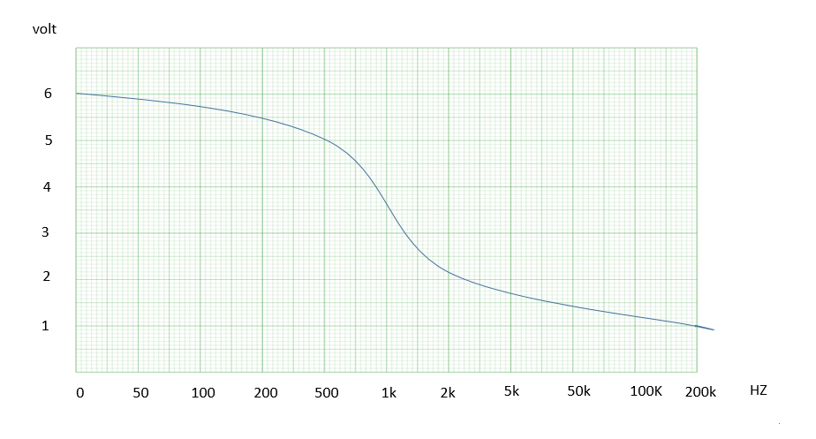

THE END